Admin 4 – Fleet Admin Data
Chapter 1 – Fleet Admin Dashboard: Module Overview & Navigation Specification
1. Introduction
The Fleet Admin Dashboard serves as the central access point for all administrative modules within the Fleet Digitalization System. It provides a unified interface for office users to navigate key operational modules, ensuring efficiency, role-based visibility, and smooth workflow access.
2. Dashboard Modules
The following module tiles are displayed on the Fleet Admin Dashboard:
- Maker List
- Master Data
- Fleet Equipment Data
- Master Lists Management
No additional tiles are included beyond these default modules. If needed, more tiles can be added in the future.
3. User Roles & Access
The system supports the following user roles:
- Admin – Full Access (Edit + View)
- Fleet Manager – Read Only
- Superintendent – Read Only
- Technical Assistant – Read Only
- Read-Only User – Restricted Viewing Only
Roles determine module visibility and editing rights.
4. Access Permissions
- Vessel-Side Users – Dashboard not visible
- Office Users – Dashboard visible but modules are not editable
- Office Admin – Dashboard visible and all modules are editable
5. Navigation Behavior
- Each module tile opens in a new section separate from the dashboard.
- Breadcrumbs are enabled to assist navigation:
  - Dashboard > Module Name
6. Dashboard Design Specifications
- Theme: Light & Dark Mode supported
- Tile Layout: Auto-layout with responsive adjustment
- Tile Size: Auto-adjust based on screen width
- Module Icons: Enabled for all tiles
7. Dashboard Filters
No dashboard-level filters are enabled:
- Search bar – No
- Recently opened modules – No
- Favorites / Pinned modules – No
8. Multi-Vessel Access Mode
The dashboard operates at the fleet level. It is not vessel-specific and remains consistent across all vessels.
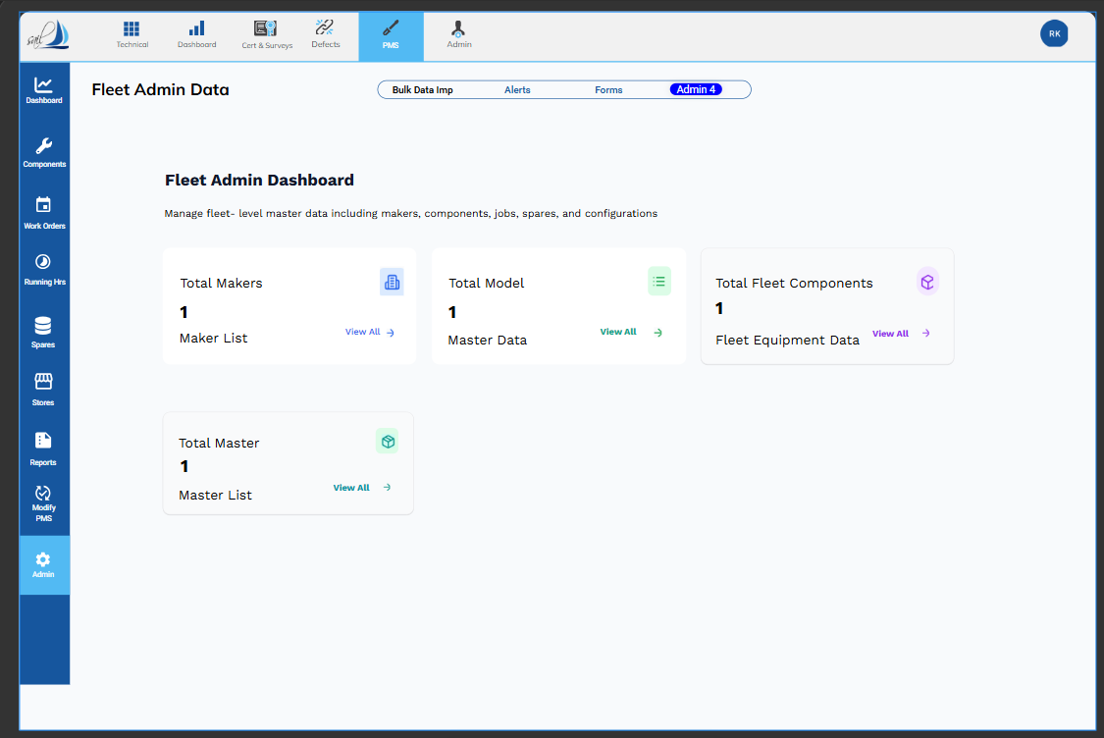

Chapter 2: Digitalization Admin – Maker List Module Specification
1. Purpose
The Maker List module serves as a centralized repository for managing all equipment manufacturers (Makers) in the Fleet Digitalization System. It ensures:
- Accurate tracking of all manufacturers linked to Fleet Components, Spares, and Jobs.
- Centralized master data management for consistency across all modules.
- Easy navigation, addition, modification, and export of Maker data for administrative purposes.
This module is crucial for maintaining data integrity and enabling downstream modules (Components, Spares, Master Data) to reference valid Maker records.

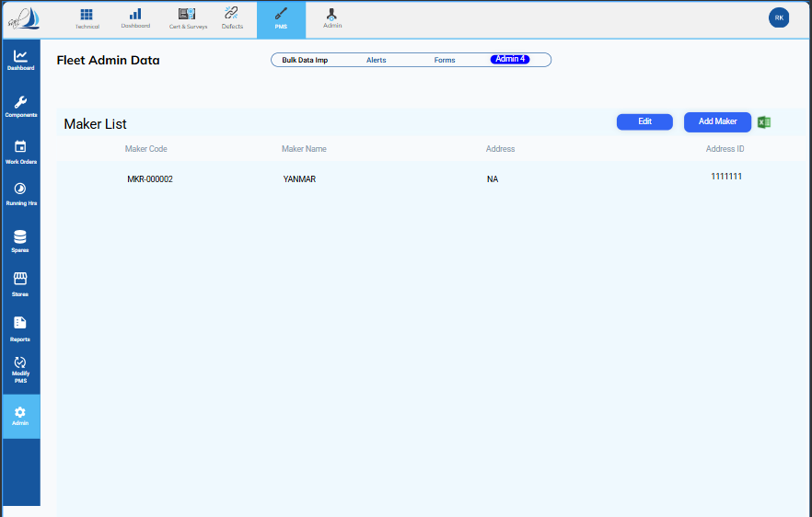

2. Screen Overview
The Maker List screen is part of Admin 4 under the Fleet Admin Dashboard. It is structured to provide users with full control over the management of Makers while maintaining usability and consistency.
2.1 Screen Sections
Section | Description | Function
Top Navigation Bar | Primary navigation showing all main modules (Technical, Dashboard, Cert & Surveys, Defects, PMS, Admin) | Allows switching between high-level modules. PMS module selection dictates context for Maker List.
Left Sidebar (Main Menu) | Vertical navigation bar with links to areas like Dashboard, Components, Work Orders, Running Hrs, Spares, Stores, Reports, Modify PMS, Admin | Secondary navigation within PMS module; selecting Admin directs to administrative tools including Maker List.
Screen Title Area (Sub-Navigation) | Displays “Fleet Admin Data” with tabs (Bulk Data Imp, Alerts, Forms, Admin 4) | Provides tertiary navigation; Admin 4 tab is selected for Maker List management.
Section Header | Displays “Maker List” | Indicates current screen view.
Action Buttons | Positioned above the table: Edit, Add Maker, Export to Excel | Enables editing existing makers, adding new makers, or exporting the list.
Maker List Table | Main content area displaying the list of all Makers with columns: Maker Name, Maker Code, Address, Address ID | Displays key information and supports selection for editing or deletion.

3. Functions and User Actions
3.1 Action Buttons Functionality
Button | Function | Workflow
Edit | Modify existing Maker details | 1. Select a Maker from the table 2. Click Edit 3. Update required fields 4. Click Save
Add Maker | Add a new Maker record | 1. Click Add New 2. Enter mandatory fields: Maker Name, Maker Code 3. Optionally enter Address and Address ID 4. Click Save
Export to Excel | Export Maker List | 1. Click Export to Excel 2. System downloads an Excel file containing all current Maker records

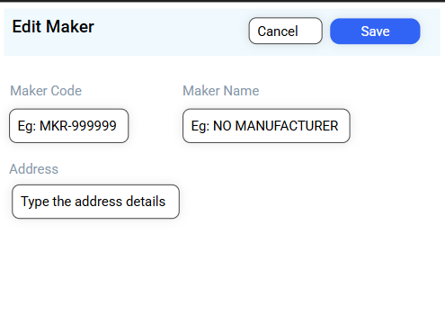

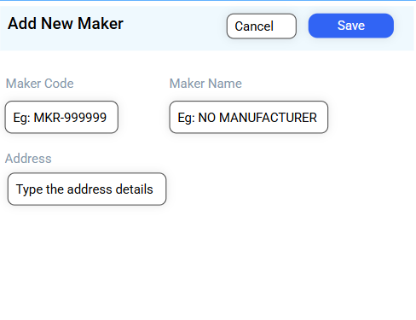

3.2 Maker List Table Features
- Sortable Columns: Users can sort the table by Maker Name or Maker Code.
- Search/Filter: Quick filtering by entering text in the search box above the table.
- Row Selection: Single selection for editing; multiple selections restricted for deletion based on business rules.

3.3 Linkages
The Maker List is referenced across multiple modules, ensuring consistent master data:
- Admin Module
  - Admin 4 → Master Data → Linked Fields: Maker Name, Maker Code
  - Admin 4 → Fleet Equipment Data → Linked Fields: Maker Name, Maker Code
  - Admin 4 → Fleet Spares → Linked Fields: Maker Name, Maker Code
- Component Module
  - Component Information → Linked Fields: Maker Name, Maker Code
- Spares Module
  - Spares Inventory → Linked Fields: Maker Name, Maker Code
These linkages ensure that changes to Maker records automatically propagate to dependent modules, preventing inconsistencies.

3.4 Metrics Card
Total Makers Card (Maker List)
Element | Description
Metric Display | Shows total number of Makers defined in the system.
Function | Provides a summary of Maker data and quick access via “View All” to navigate directly to the Maker List screen.
Action | Clicking “View All” opens Maker List with all records displayed in table format.

4. Navigation Flow
Access Path:
Fleet Admin Dashboard → Admin Module → Admin 4 Tab → Maker List
Role-Based Access:
- Admin users can Add, Edit, Delete, or Export Maker data.
- Read-only users can view the Maker List and export data.
- Deletion is restricted if Maker is linked to active Fleet Components, Jobs, or Spares.
Screen Flow Example:
- Admin clicks Total Makers Card on Dashboard.
- Maker List table loads with all existing Makers.
- Admin can Edit, Add, or Export records.
- Any changes are validated and saved, updating all linked modules.

5. Validations & Business Rules
Rule | Description
Mandatory Fields | Maker Name and Maker Code cannot be blank.
Unique Maker Code | Each Maker Code must be unique.
Deletion Restriction | Makers linked to active Components, Jobs, or Spares cannot be deleted.
Data Format | Maker Code alphanumeric; Address fields accept text and numeric combinations.
Audit Trail | All changes to Maker records are logged with timestamp, user, and action.

6. Error Handling & Notifications
- Duplicate Maker Code: Shows error “Maker Code already exists.”
- Incomplete Mandatory Fields: Shows error “Please enter all required fields.”
- Linked Record Deletion Attempt: Shows warning “Cannot delete Maker – linked to active records.”
- Successful Save: Displays confirmation “Maker details saved successfully.”

7. Maker List Table:
Column Name | Description / Purpose
Maker Code | Unique alphanumeric identifier for each Maker. Mandatory field. Used for linking to Components, Spares, Jobs, and Master Data.
Maker Name | Name of the Manufacturer / Maker. Mandatory field. Displayed throughout the system wherever the Maker is referenced.
Address | Physical or mailing address of the Maker. Optional field but helps with identification and correspondence.
Address ID | System-generated unique identifier for the Maker’s address record. Supports internal data management and mapping.

8. Summary
The Maker List module is a core administrative tool in the Fleet Digitalization System. Its key purposes are:
- Centralizing all manufacturer information.
- Linking Makers to Components, Spares, and Jobs for data consistency.
- Providing intuitive navigation, search, and actionable Metrics Cards.
- Supporting comprehensive validation and role-based access for secure management.
By maintaining accurate Maker data, the module ensures integrity across all fleet management operations, enabling seamless downstream processes in the PMS and related modules.

Chapter 3: Digitalization Admin – Master Data List Specification

1. Purpose
The Master Data module manages all Fleet Equipment Models and associated reference information in the Fleet Digitalization System. Its main objectives are:
- Centralization of fleet equipment models: Ensures consistency across all fleet modules.
- Linkage to Fleet Components: Supports associations with jobs, spares, and vessel assignments.
- Actionable metrics & navigation: Provides quick access via dashboard cards.
- System-wide master configuration: Supports dropdowns, reference tables, and foundational master data.

2. Screen Overview
Access Path:
Fleet Admin Dashboard → Admin Module → Admin 4 Tab → Master Data
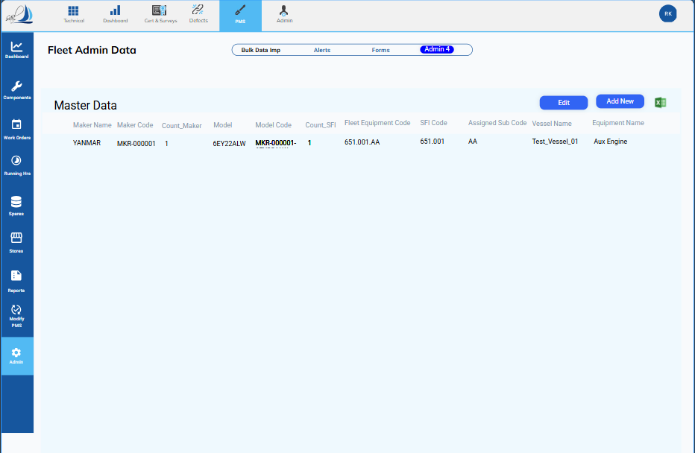

2.1 Screen Sections
Section | Description | Function
Top Navigation Bar | Modules: Technical, Dashboard, Cert & Surveys, Defects, PMS, Admin | Switch between main system modules. PMS selection sets the screen context.
Left Sidebar (Main Menu) | Links: Dashboard, Components, Work Orders, Running Hrs, Spares, Stores, Reports, Modify PMS, Admin | Secondary navigation within PMS. Selecting Admin displays administrative options.
Screen Title Area | Displays “Fleet Admin Data” with sub-tabs: Bulk Data Imp, Alerts, Forms, Admin 4 | Tertiary navigation. Admin 4 tab selected to display Master Data module.
Section Header | Displays “Master Data” | Identifies the current screen content.
Action Buttons | Edit, Add New, Export to Excel | Enable creation, modification, and export of Master Data records via popup forms.
Master Data Table | Lists all fleet equipment models with columns such as Fleet Equipment Code, Fleet Equipment Name, Model, Model Code, Vessel mapping | Main content area for viewing, editing, filtering, and managing master data. Filtering options available by Maker, Model, or Vessel.

3. Functions and User Actions
3.1 Action Buttons
Button | Function | Workflow
Edit | Modify an existing Master Data record | 1. Select row  2. Click Edit  3. Pop-up form opens  4. Update fields  5. Click Save
Add New | Add a new Master Equipment record | 1. Click Add New  2. Pop-up form opens  3. Enter all mandatory fields  4. Click Save
Export to Excel | Export Master Data table | 1. Click Export  2. System generates Excel file for download

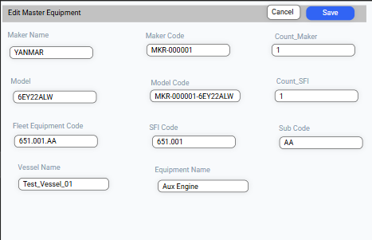

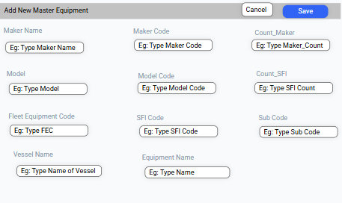

3.2 Metrics Card
Total Model Card (Master Data)
Element | Description
Metric Display | Total number of defined Fleet Equipment Models in the system
Function | Provides a quick overview. Clicking “View All” navigates to the full Master Data list (no automatic filtering).

4. Master Data Table Columns
Column Name | Description / Purpose
Maker Name | Name of the equipment manufacturer (linked from Maker List)
Maker Code | Unique code for the manufacturer (linked to Maker List)
Count_Maker | Number of Fleet Equipment records associated with this Maker
Model | Name of the fleet equipment model
Model Code | Unique identifier for the model used across system modules
Count_SFI Code | Number of SFI Codes linked to this Fleet Equipment or Model
Fleet Equipment Code | Unique code representing the fleet equipment type; 10 characters including periods
SFI Code | Standardized sub-assembly classification code (Ship’s Fleet Item Code)
Assigned Sub Code | Specific sub-component code assigned to the Fleet Equipment
Vessel Name | Name of the vessel where the equipment is installed (if mapped)
Equipment Name | Descriptive name of the specific equipment or component on the vessel
5. Linkages
Master Data is referenced across multiple modules for system integrity:
- Admin Module:
  - Admin 4 → Fleet Equipment Data → Linked Fields: Fleet Equipment Code, Fleet Equipment Name, Model, Model Code
- Component Module:
  - Component Information → Linked Fields: Fleet Equipment Code, Fleet Equipment Name, Model, Model Code
- Job Module:
  - Jobs → Linked via Fleet Job Information to Fleet Equipment Code
- Spares Module:
  - Fleet Spares → Linked via Fleet Spares Information to Fleet Equipment Code

6. Navigation Flow
Access Path:
Fleet Admin Dashboard → Admin Module → Admin 4 → Master Data
Screen Flow Example:
- Admin clicks Total Model Card on Dashboard.
- Master Data table loads with all records.
- Admin can Edit or Add New via popup forms or Export to Excel.
- Filtering available by Maker, Model, to narrow displayed records.

7. Validations & Business Rules
Rule | Description
Mandatory Fields | Fleet Equipment Code, Fleet Equipment Name, Model Code, Model, Maker, Maker Code, Equipment Name cannot be empty
Unique Codes | Fleet Equipment Code must be unique across the system
Code Format | Fleet Equipment Code must be exactly 10 characters including periods
Deletion Restriction | Cannot delete Master Data if linked to active Fleet Components, Jobs, or Spares
Maker Link | Maker and Maker Code must exist in Maker List before assignment
Status Toggle | Is Active flag ensures proper visibility in linked modules
Role-Based Access | Only Office Admin can add or edit Master Data
Audit Trail | All changes logged with timestamp, user, and action for traceability

8. Error Handling & Notifications
- Duplicate Fleet Equipment Code → “Code already exists”
- Mandatory field missing → “Please fill all required fields”
- Attempting deletion of linked data → “Cannot delete – record is linked to active records”
- Successful save → “Master Data saved successfully”

9. Summary
The Master Data module provides centralized management of all Fleet Equipment models. Key features include:
- Popup-based creation and modification for controlled editing
- Filtering by Maker, Model, or Vessel for quick access
- Integration with Components, Jobs, and Spares modules
- Strict validation rules and audit trails
- Role-based access ensuring only authorized personnel can modify master records
- Export functionality for reporting and external use
This ensures data integrity, operational efficiency, and consistency across all fleet digitalization modules.

Chapter 4: Fleet Equipment Data – Vessel Machinery & Component Structure

1. Purpose
The Fleet Equipment Data module manages all vessel-specific and generic fleet components in the Fleet Digitalization System. The module ensures:
- Centralized management of Fleet Components.
- Mapping components to Jobs, Spares, and Vessel instances.
- Role-based access with Office Admin privileges for add/edit operations.
- Data integrity via Fleet Equipment Codes and cross-module linkages.
- Easy navigation and actionable metrics for Fleet Equipment.

2. Access & Navigation
Path: Fleet Admin Dashboard → Admin Module → Admin 4 Tab → Fleet Equipment Data
- Clicking Total Fleet Components Card navigates here.
- Tree View displays all parent and child components for every vessel.

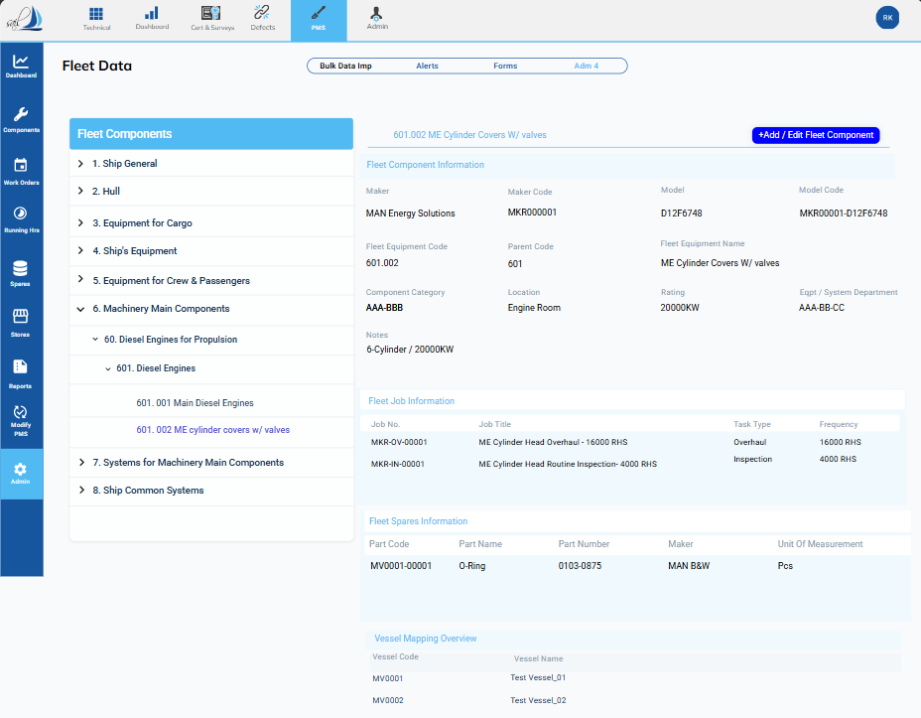

3. Component Information Section
3.1 Screen Overview
The Component Information section manages all fleet components and their hierarchical relationships. Each component is linked to Fleet Equipment Codes, jobs, spares, and vessels. The section allows viewing, adding, editing, and mapping of components.
Main Screen Sections:
Section | Description
Component Tree | Hierarchical tree view of all fleet components grouped by parent equipment. Displays Parent → Child → Sub-component relationships.
Component Details Panel | Displays detailed data of the selected component from the tree. Editable only via Add/Edit popup.
Action Buttons | Add Component, Edit Component, Add Sub-Component, Delete Component, Export to Excel.
Metrics / Summary (Optional) | Shows total components, components with jobs/spares linked.

3.2 Component Tree
The Fleet Equipment components are organized in a multi-level tree structure:
Format:
Parent → Child → Sub-child → Further Sub-component → Unique Tag
Example:
1 Hull
└─ 11 Engine
├─ 111 Cylinder
│ ├─ 111.111 Cylinder Head Assembly
│ │ ├─ 111.111.AA Cylinder Head Bolt – AA
│ │ └─ 111.111.AB Cylinder Head Bolt – AB
│ └─ 111.112 Cylinder Cover Assembly
└─ 112 Lubrication System
└─ 112.111 Oil Pump Assembly
Key Points:
- Each node represents a Fleet Equipment component or sub-component.
- Parent-Child Relationships: Parent nodes group sub-components logically.
- Unique Tags: Final level (leaf nodes) represents individual physical components or assemblies.

3.2 Tree View Features
Feature | Description
Expand/Collapse | Users can expand or collapse any node to view sub-components.
Node Selection | Selecting a node displays Component Details in the right panel.
Add Sub-Component | Available for any node except leaf nodes; opens a popup form.
Edit Node | Opens a popup to edit the selected component's details.
Delete Node | Removes component if not linked to Jobs, Spares, or Vessel instances (Office Admin only).
Mapping | Leaf nodes can be linked to Fleet Jobs, Fleet Spares, and Vessel Components.

3.3 Component Details Panel
Displays detailed attributes for the selected component. Editable via Add/Edit Component popup.
Field Name | Input Type | Mandatory | Notes / Validation
Fleet Component Code | Auto-fill / Alphanumeric (10) | Yes | Unique identifier; links to Master Data
Component Code | Alphanumeric (10) | Yes | Unique within Fleet Component; used for linking Jobs/Spares
Component Name | Text | Yes | Descriptive name
Parent Component Code | Dropdown / Auto-fill | No | Links to parent in hierarchy (Tree view supported)
Maker Code | Dropdown / Alphanumeric | Yes | Links to Maker List
Rating | Numeric / Text | No | Technical rating of component
Location | Text | No | Physical or functional location on vessel
Is Active | Select (Yes/No) | Yes | Controls visibility in other modules
Notes | Large Text | No | Administrative or operational notes
Date of Installation | Date Picker | No | Installation date of component
Last Maintenance Date | Date Picker | No | Tracks last maintenance
Criticality Level | Select (High/Medium/Low) | No | Risk or importance level for planning

3.4 Action Buttons & Popups
Button | Function | Workflow / Popup
Add Component | Adds a new top-level component | Opens Add Component Popup → Fill mandatory fields → Validate → Save → Refresh tree
Add Sub-Component | Adds a child to selected component | Opens Add Sub-Component Popup → Select parent → Fill details → Validate → Save → Refresh tree
Edit Component | Modify component details | Opens Edit Component Popup pre-filled → Update fields → Validate → Save → Refresh panel
Delete Component | Remove component | Select component → Confirm deletion → Validate no linked Jobs/Spares → Delete → Refresh tree
Export to Excel | Export tree or selected components | Generates Excel file with all displayed records

3.5 Add/Edit Component Popup Form
Popup Sections:
- Basic Information
  - Fleet Equipment Code (auto-filled from Master Data)
  - Component Code
  - Component Name
  - Parent Component Code (dropdown if sub-component)
- Technical Details
  - Rating
  - Location
- Additional Information
  - Notes
  - Is Active (Yes/No)
- Action Buttons
  - Save → Validate mandatory fields, unique codes → Save → Refresh table/tree
  - Cancel → Close popup without changes
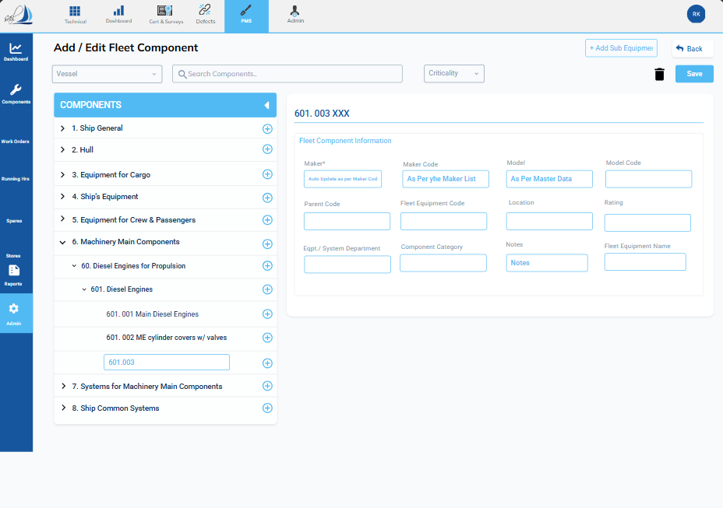

Validations:
- Fleet Equipment Code must exist in Master Data.
- Component Code must be unique within Fleet Equipment.
- Maximum length of codes: 10 characters including separators (“.”).
- Mandatory fields: Fleet Equipment Code, Component Code, Component Name.
- Only Office Admin can add/edit/delete.

3.6 Component Linkages
Each component is linked to:
- Master Data: Fleet Equipment Code → Component Code & Name
- Fleet Jobs: Linked via Fleet Job Information module
- Fleet Spares: Linked via Fleet Spares Information module
- Vessel Mapping: Each component can be mapped to one or multiple vessels via Vessel Component Mapping

3.7 Search & Filter Options
Filter | Description
Fleet Equipment Code | Dropdown/Auto-fill filter
Component Name | Partial match search
Parent Component Code | Dropdown to show only children of selected parent
Is Active | Toggle Active / Inactive
Rating / Location | Optional text search

3.8 Error Handling & Notifications
Scenario | Message
Duplicate Fleet Equipment Code | “Component Code already exists for this Fleet Equipment.”
Mandatory field missing | “Please fill all required fields.”
Attempt to delete linked component | “Cannot delete – linked to active Jobs or Spares.”
Save success | “Component saved successfully.”
Mapping success | “Component successfully mapped to selected vessels.”

3.9 Metrics / Summary
Optional summary cards can display:
- Total Components
- Components with jobs assigned
- Components with spares assigned
Clicking a metric can optionally filter the tree/table view.

✅ 3.10 Summary
The Component Information Section provides a centralized view and management interface for fleet components. Features include:
- Hierarchical tree structure
- Detailed component data with Add/Edit/Delete via popups
- Parent-child relationships and sub-component management
- Linking to Jobs, Spares, and Vessel instances
- Role-based access for Office Admin
- Full validation, error handling, and audit trail

4. Job Information Section
Purpose
The Job Information Section captures, manages, and tracks all maintenance jobs linked to fleet components. It ensures correct scheduling, assignment, vessel mapping, priority handling, and workflow management within the Planned Maintenance System (PMS).

4.1 Job Overview Table (Fleet Job Information List)
Role: Provides a comprehensive list of all jobs linked to a component.
Column Header | Data Type / Notes
Job No. | Unique identifier (e.g., MKR-OV-00001).
Job Title | Descriptive task name (e.g., ME Cylinder Head Overhaul - 16000 RHS).
Task Type | Categorization (Overhaul, Inspection, Service).
Frequency | Running hours interval (e.g., 4000 RHS).
Interval Value + Unit | Calendar interval (e.g., 6 Months).
Assigned To | Single role/person responsible (e.g., 2nd Engineer).
Approver | Single role/person approving (e.g., Chief Engineer).
Job Priority | Urgency (High, Medium, Low).
Class Related | Yes / No for Classification compliance.
Department | Owning department (Engine, Deck, etc.).
Criticality | Impact if missed (Critical / Non-Critical).
Brief Work Description | Mandatory instructions for the job.
Actionable Features:
- Double-click → Job Details Screen (read-only).
- Search / Filter by Job No., Task Type, Department, Status.
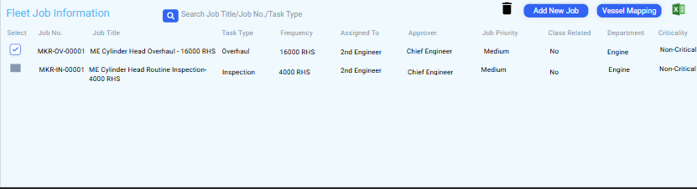

4.2 Add New Job Information Screen
Purpose: Define a new maintenance job and associate it with a Fleet Equipment code.
Fields & Rules:
Field Name | Input Type / Notes
Job No. | Unique alphanumeric; mandatory
Job Title | Text; mandatory
Task Type | Select/Input; multiple entries allowed from master list
Maintenance Basis | Select/Input; multiple entries allowed (Calendar / Running Hours / Cycle Count)
Interval Value | Numeric; mandatory for calendar-based jobs
Unit | Select/Input; e.g., Months, Weeks
Interval Running Hour | Numeric; 0 if Calendar-based
Assigned To | Single role/person; mandatory
Approver | Single role/person; mandatory
Job Priority | High / Medium / Low; mandatory
Class Related | Yes / No; mandatory
Department | Mandatory
Criticality | Critical / Non-Critical; mandatory
Is Active | Yes / No toggle
Brief Work Description | Mandatory text area
Action Buttons:
- Save → Saves job and links to component.
- Cancel → Discards input.
Validation Rules:
- End Date > Start Date
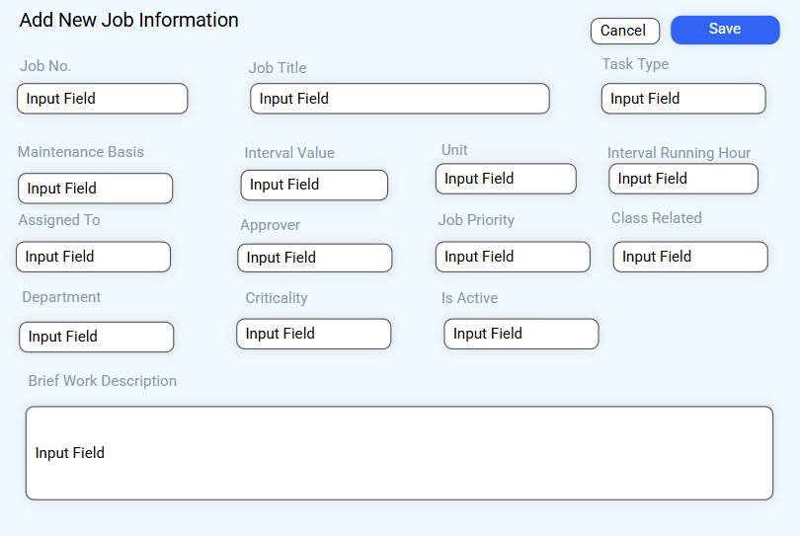
- Mandatory fields cannot be blank

4.3 Job Details Screen (Read-Only)
Purpose: Displays a single job’s details without editing.
Sections:
Section | Fields / Content | Purpose
Job Core Data | Job No., Job Title, Task Type, Maintenance Basis, Interval Running Hour, Interval Value + Unit | Unique identifiers & scheduling
Workflow & Admin | Assigned To, Approver, Job Priority, Class Related, Department, Criticality, Is Active | Responsibility & admin status
Job Mapped Vessel Detail | Vessel Code, Vessel Name | Confirms vessel assignment
Brief Work Description | Mandatory instructions | Work scope
Action Button:
- Edit → Opens Edit Job Details Screen
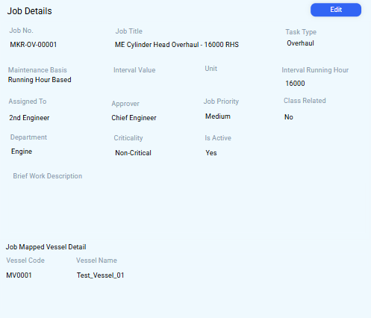

4.4 Edit Job Details Screen
Purpose: Modify existing job parameters.
Access: Via Edit button on Job Details Screen.
Action Buttons:
- Save → Updates the job and future PMS scheduling
- Cancel → Discards changes
Validations: Same as Add Job screen
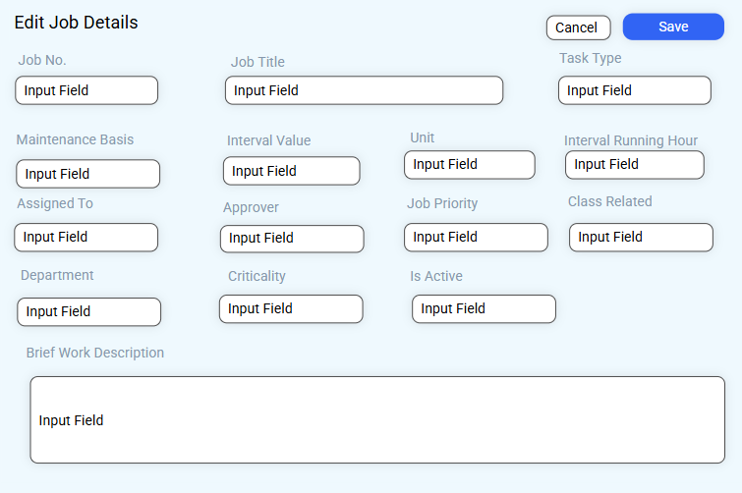

4.5 Vessel Mapping Screen
Purpose: Link jobs to vessels where the component exists.
Logic:
- One Equipment → Many Jobs
- Jobs can be linked to multiple vessels
- A vessel cannot have duplicate jobs for the same component
Table Columns:
Column | Notes
Select | Checkbox for mapping/unmapping
Vessel Code | e.g., MV0001
Vessel Name | e.g., Test_Vessel_01
Action Buttons:
Button | Functionality
Search | Find vessels by Code or Name
Map | Link selected vessels to the job
Remove Map | Unlink selected vessels
 | 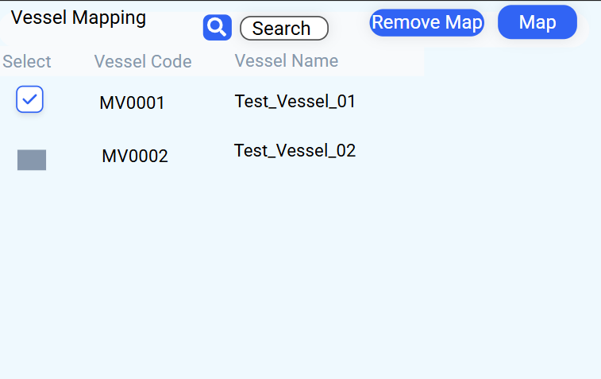

4.6 Job Workflow & Integration
- Component Information → Jobs are linked to components.
- Spares Information → Jobs can reserve spares required.
- Vessel Mapping → Job definitions are applied to selected vessels.
- Audit Trail → Logs all changes, approvals, and mappings.

5. Spares Information Section
Purpose
The Spares Information Section manages all spare parts linked to fleet equipment. It enables users to define, view, assign, and manage spares, linking them to jobs, components, and vessels. This ensures correct spare availability across the fleet and proper integration with inventory and maintenance planning.

5.1 Fleet Spares Information Screen
Title: Fleet Spares Information
Purpose: Display all spares associated with the selected Fleet Equipment Code and allow management of those spares.

5.2 Spares Table Fields
Column Header | Data Type / Notes | Example
Part Code | Unique alphanumeric identifier | MV0001-00001
Part Name | Descriptive name | O-Ring, Gasket
Part Number | Manufacturer reference | 0103-0875
UOM | Unit of Measurement | Pcs (Pieces)
Drawing No. | Reference to technical drawing | AAA-BBB
Position No. | Component assembly location | 1, 2
Maker | Manufacturer name | MAN B&W
Criticality | Indicates safety/operational importance | Non-Critical
Is Active | Yes / No toggle | Yes
Notes:
- multiple Fleet Equipment Codes can share the same spare.
- Vessel Mapping shows which vessels the spare is applied to.
- Soft delete: Deactivated instead of permanent removal.
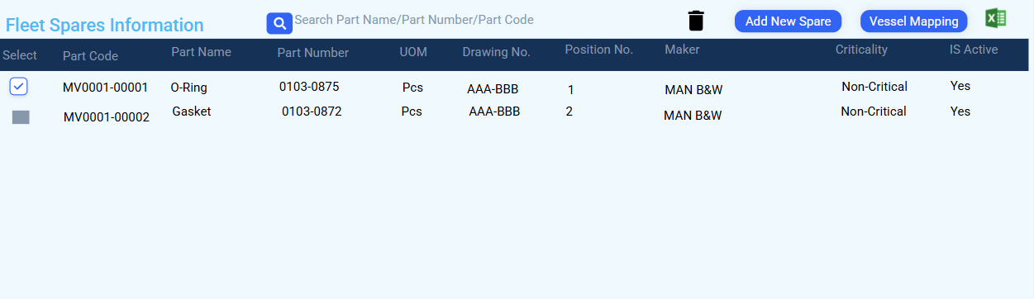

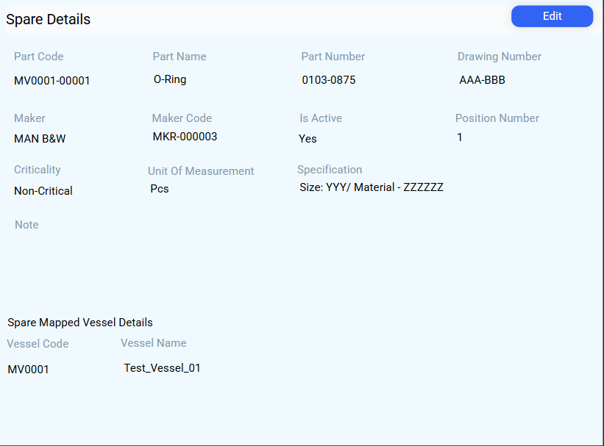
5.3 Action Buttons

Button Name | Functionality | Notes
Search | Locate spares by Part Code, Part Name, Part Number, UOM, Maker, Drawing No., Position No. | Quick filtering
Add New Spare | Opens Spare Selection/Creation Form | Pulls from Master Spare List
Trash/Delete | Deactivates selected spare(s) | Requires checkbox selection
Vessel Mapping | Manage which vessels the spare applies to | Only vessels with the component can be linked
Export/Excel | Exports current table to Excel | Standard export

5.4 Add / Edit Spare Pop-up
Purpose: Create or link a spare to Fleet Equipment Code.
Fields:
Field Name | Input Type / Notes | Mandatory
Part Code | Filed by user | Yes
Part Name | Filed by user | Yes
Part Number | Filed by user | No
UOM | Filed by user | Yes
Drawing No. | Filed by user | No
Position No. | Numeric / Input | Yes
Maker | Auto-fill / Select | Yes
Criticality | Select | Yes
Is Active | Yes / No toggle | Yes
Action Buttons:
- Save: Links spare to Fleet Equipment and updates table.
- Cancel: Closes popup without saving.
Validation Rules:
- Part Code + Fleet Equipment combination must be unique.
- Criticality is informational but mandatory.
- Is Active independent of component/job status.

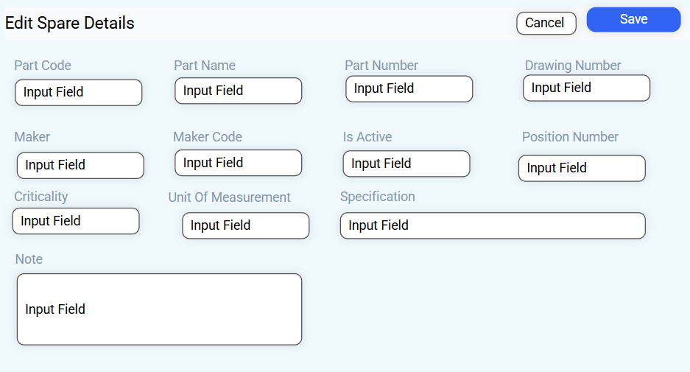

5.5 Vessel Mapping for Spares
Purpose: Assign spares to vessels where the component exists.
Rules:
- Only vessels that have the linked component can receive spares.
- One spare cannot be linked twice to the same vessel for the same component.
- A spare can be linked to multiple vessels.
Screen Layout:
Column | Notes
Select | Checkbox for mapping/unmapping
Vessel Code | e.g., MV0001
Vessel Name | e.g., Test_Vessel_01
Action Buttons:
- Search: Find vessels by Code or Name
- Map: Link spare to selected vessels
- Remove Map: Unlink spare from selected vessels


5.6 Integration & Workflow
- Component Information Section: Spares linked to Fleet Equipment Code.
- Job Information Section: Jobs can reserve spares for maintenance scheduling.
- Vessel Mapping: Ensures the correct spare is assigned only to vessels with the component.
- Audit Trail: Logs all spare additions, edits, deletions, and vessel mappings.

- Table shows all spares linked to selected Fleet Equipment.
- Pop-ups manage adding new spares or mapping to vessels.
- Action buttons provide easy management and export options.

6. Vessel Mapping Overview Section
Purpose
The Vessel Mapping Overview Section manages the linkage of Fleet Equipment Codes and their associated components to physical vessels. It ensures proper assignment of equipment and components while maintaining integrity with linked jobs and spares.
This updated section also includes the workflow for mapping additional components after linking a vessel.

6.1 Vessel Mapping Overview Screen
Purpose: Link or unlink Fleet Equipment Codes to vessels within the fleet.
Screen Sections:
Section | Role / Content
Title | Vessel Mapping Overview
Data Table | Displays all vessels in the fleet
Columns | Select (checkbox), Vessel Code, Vessel Name
 | 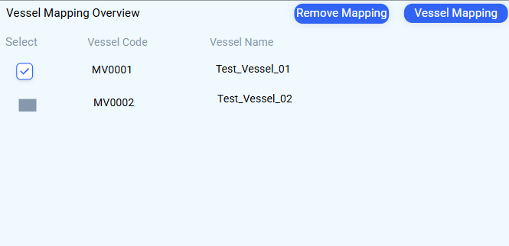

Action Buttons:
Button Name | Functionality | Process Flow
Vessel Mapping | Links Fleet Equipment Code to selected vessel(s) | 1. Select vessels → 2. Click Vessel Mapping
Remove Mapping | Deactivates Fleet Equipment Code mapping from selected vessel(s) | 1. Select vessels → 2. Click Remove Mapping (cannot remove if linked jobs/spares exist)
Search/Filter:
- Filter by Vessel Code, Vessel Name, Vessel Type, Fleet Group

6.2 Vessel Mapping Search & Selection

Purpose: Find and select specific vessels from the fleet for mapping.
Section | Role / Content
Title | Vessel Mapping
Search Bar | Enter Vessel Code or Name; magnifying glass executes search
Data Table | Displays vessels matching criteria with selection checkbox
Action Buttons:
Button Name | Functionality | Process Flow
Map | Links Fleet Equipment Code to selected vessel(s) | 1. Select vessels → 2. Click Map
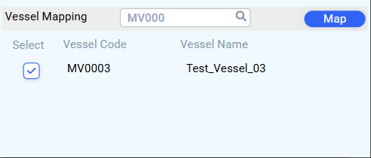

6.3 Vessel Component Mapping Overview
Purpose: Manage mapping between a Fleet Equipment Code (template) and physical component instances on a vessel.
Workflow:
- Link Fleet Equipment Code to vessel (Step 1).
- Double-click the vessel to see currently linked components.
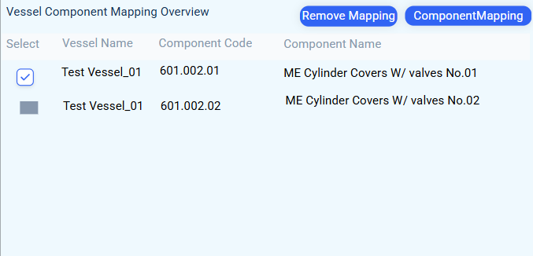
- View, remove, or add more components via Component Mapping popup.

Table Columns:
Column | Notes | Example
Select | Checkbox for mapping actions | –
Vessel Name | Vessel containing the components | Test_Vessel_01
Component Code | Unique vessel-side asset code | 601.002.01
Component Name | Descriptive name including position | ME Cylinder Covers w/ valves No.01
Action Buttons:
Button Name | Functionality | Process Flow
Component Mapping | Opens popup to map additional components from the vessel | 1. Click → popup shows all components for that vessel → 2. Search/select → 3. Click Map
Remove Mapping | Deactivates mapping between Fleet Equipment Code and component(s) | 1. Select mapped component(s) → 2. Click Remove Mapping (dependency checks applied)
Rules & Constraints:
- Fleet Equipment Code → multiple components within the same vessel allowed
- Component Code may vary between vessels
- No limit on number of components mapped at once
- Cannot remove mapping if jobs or spares exist for that component on the vessel
- Removal deactivates the link (soft delete)

6.4 Component Mapping Search & Selection
Purpose: Search and select physical components on a vessel for mapping.
Sections:
Section | Role / Content
Title | Component Mapping
Search Bar | Filter by Component Code or Component Name; magnifying glass executes search
Data Table | Displays filtered components with selection checkbox
Action Buttons:
Button Name | Functionality | Process Flow
Map | Links selected Component Code(s) to Fleet Equipment Code | 1. Search/select components → 2. Click Map

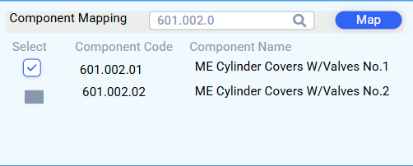

6.5 Workflow & Integration
- Step 1 – Link Fleet Equipment Code → Vessel
- Step 2 – Double-click vessel → View linked components
- Step 3 – Map additional components via popup
- Step 4 – Remove mapping (soft delete; dependency checks applied)
- Audit Trail: Logs all mapping/unmapping actions (user, date, time)
- Fleet Equipment → Vessel: One Fleet Equipment Code can map to multiple vessels
- Vessel → Fleet Equipment: Vessel can have multiple Fleet Equipment Codes
- Fleet Equipment → Vessel Components: Can map multiple components per vessel

Section 7 – Fleet Equipment & Data Linkages
Purpose
This section defines the relationships and linkages between Fleet Equipment, Components, Jobs, and Spares across the PMS system. It ensures that all entities are connected correctly for scheduling, maintenance, and reporting.

7.1 Fleet Equipment Data Linkages
Module: Admin → Master Data / Components
Source Module / Section | Linked Fields | Target Module / Section | Notes
Admin → Master Data | Fleet Equipment Code, Fleet Equipment Name | Components Module → Component Information | All components reference the Fleet Equipment Code and Name as a master linkage
Components Module → Component Information | Fleet Equipment Code, Fleet Equipment Name | Admin Master Data | Reverse lookup to ensure components remain linked to the master fleet equipment
Notes:
- Fleet Equipment Code is unique and serves as the primary key for all linkages.
- Any updates to Fleet Equipment Code or Name in Admin → Master Data automatically reflect in Components.

7.2 Fleet Job Information Linkages
Module: Components → Jobs
Source Module / Section | Linked Fields | Target Module / Section | Notes
Components Module → Jobs | Job No. | Fleet Job Information | Each job is uniquely identified by Job No. and linked to the corresponding component(s) via Fleet Equipment Code
Fleet Job Information | Job No., Fleet Equipment Code | Components → Jobs | Ensures that scheduled jobs correspond to the correct component and fleet equipment
Notes:
- Job No. is unique per job definition.
- Jobs linked to components cannot be deleted without breaking dependency rules.

7.3 Fleet Spare Information Linkages
Module: Components → Spares
Source Module / Section | Linked Fields | Target Module / Section | Notes
Components Module → Spares | Part Code | Fleet Spare Information | Spares are linked to components using Part Code
Fleet Spare Information | Part Code, Fleet Equipment Code | Components Module → Spares | Ensures that spares are correctly assigned to their respective fleet equipment and components
Notes:
- Part Code is unique per spare but can be linked to multiple Fleet Equipment Codes.
- Vessel mapping for spares only applies to vessels that have the linked component.

7.4 Summary Diagram – Linkages
Key Points:
- Fleet Equipment Code is the central master linkage.
- Jobs and Spares are tied to Components → which in turn are linked to Fleet Equipment.
- Vessel mapping applies to both Jobs and Spares according to the components assigned.
- All linkages are enforced with dependency checks to prevent deletion or duplication.

Chapter 5 – Master List Module Specification
Purpose
The Master List module allows administrators to manage system-wide dropdowns, lookup values, and foundational configuration items. It ensures consistency across Jobs, Components, Spares, and Vessel management.
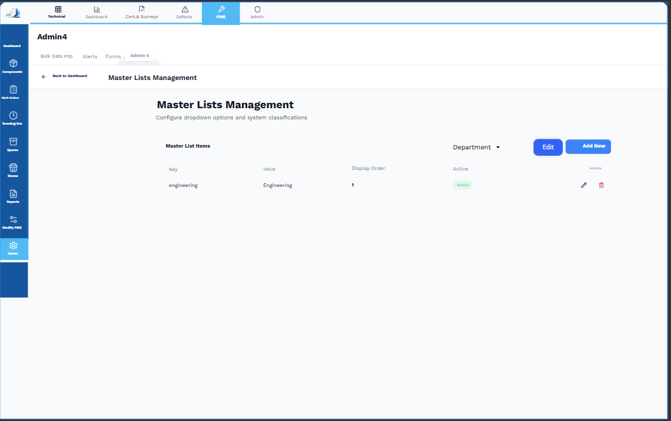

5.1 Master List Card
Card Name / Destination Link | Metric Displayed | Function
Total Master Card (Master List) | Count of generic or other Master entities | Shows a summary of broader master data entities. Clicking View All navigates to the Master List screen, which contains lookups, common variables, or other configuration items.

5.2 Master Lists Management Screen
Purpose: Central location for configuring system dropdown options and classifications (e.g., Department, UOM, Task Type).
5.2.1 Header and Navigation
Element | Description
Top Tabs | Accessed via PMS → Admin module → Admin 4 tab (alongside Bulk Data Import and Alerts)
Back to Dashboard | Navigation link to return to Fleet Admin Dashboard overview

5.2.2 Control Buttons
Button / Selector | Functionality
Department Dropdown | Selector to choose which Master List to manage (e.g., Department, UOM, Task Type)
Add New | Opens form (or inline fields) to create a new item in the selected Master List
Edit (Top Button) | Opens modification form for the currently selected item
Notes:
- Add/Edit forms include validations such as mandatory Value field and Display Order numeric check.
- Only active Master Lists are displayed by default.

5.2.3 Master List Items Data Grid
Column Header | Description | Notes
Key | Unique, non-editable identifier/code for the list item (e.g., engineering) | Used for system linkages and database reference
Value | Display name shown to users in dropdowns (e.g., Engineering) | Editable field
Display Order | Numeric sequence determining order in dropdowns | Ensures logical ordering
Active | Status toggle for the item | Allows logical deactivation without deletion
Actions | Row-level action buttons | See 5.2.4 below

5.2.4 Row-Level Action Buttons
Button Icon | Functionality | Business Rule (Hard Linkage Check)
Pencil Icon (Edit) | Opens edit form for that row to update Value or Display Order | Key is non-editable
Trash Can Icon (Delete) | Deletes item from Master List | Deletion prevented if item is linked in any active Job, Spare, Component, or Vessel record

5.3 Workflow & Integration
- Selecting Master List Type: Administrator chooses the dropdown type (e.g., Department) using the top selector.
- Adding a New Item: Click Add New, fill Value and Display Order, save. The system validates uniqueness of Key.
- Editing an Item: Click pencil icon, modify editable fields, save. Key remains unchanged.
- Deleting an Item: Click trash icon. System performs hard linkage check; if item is in use, deletion is blocked.
- Activation / Deactivation: Toggle Active status to enable/disable item in dropdowns without removing database reference.

5.4 Developer Notes
- Master Lists are referenced in multiple PMS modules: Jobs, Components, Spares, and Vessel Mapping.
- Validation:
  - Value cannot be empty
  - Display Order must be numeric
  - Active toggle independent per item
- Linkage Check: Prevents deletion if item is referenced in active system entities
- Audit Trail: Logs all add/edit/delete actions with user, timestamp, and action type

CHAPTER 6: Bulk Data Import – Fleet Admin Data
I've analyzed the provided screenshots, which detail the Fleet Components flow, Job/Spare management, Mapping procedures, and the Bulk Data Import setup. The analysis confirms the exact fields, buttons, and visual flow for the system we have been documenting.
Here is a breakdown of the screens and a detailed analysis of the Bulk Data Import screen, addressing your note about the "Fleet Data Import" switch.

🛠️ Analysis of Provided Screens
1. Fleet Components Data Screen (Admin 4)
- Screen: (Titled "Fleet Data")
- Confirmation: Confirms the structure of the main screen: Component Tree View (left), Fleet Component Information, Fleet Job Information, Fleet Spares Information, and Vessel Mapping Overview (bottom).
- Key Button: The +Add / Edit Fleet Component button is visible, confirming the entry point for component template modification.
2. Fleet Job Information
- List View: confirms the buttons: Search, Trash Can (Delete), Add New Job, Vessel Mapping, and Export (Excel icon).
- Add/Edit Job: and confirm the fields used for defining a job: Job No., Job Title, Task Type, Maintenance Basis, Interval Value, Assigned To, Approver, Department, Criticality, etc.
- View Job Details: confirms the Job Mapped Vessel Detail section in the read-only view.
3. Fleet Spares Information
- List View: confirms the buttons: Search, Trash Can (Delete), Add New Spare, Vessel Mapping, and Export (Excel icon).
- Add/Edit Spare: and confirm the fields used for defining a spare: Part Code, Part Name, Maker, Maker Code, UOM, Criticality, Specification, etc.
- View Spare Details: confirms the Spare Mapped Vessel Details section.
4. Mapping Flow
- Vessel Mapping Overview: confirms the Remove Mapping and Vessel Mapping buttons.
- Vessel Mapping Search: confirms the Map button and the search functionality for selecting new vessels.
- Vessel Component Mapping: confirms the Remove Mapping and ComponentMapping buttons for linking the fleet template to the specific physical asset instances.
- Component Mapping Search: confirms the search field and Map button for linking the asset instance.

5. Bulk Data Import Screen Analysis
The Bulk Data Import screen provides a structured workflow for data entry, confirming the need for templates and historical tracking.
5.1 Import Workflow and Controls
Element | Description / Function
Select Vessel | An important control: all imports are associated with the selected vessel. This means bulk imports are primarily used for vessel-specific setup, not global master data (though global master data like Maker List is imported first).
Fleet Data Import Switch | This toggle switch controls the import process. When ON (active), the system is ready to accept file uploads based on the selected template. When OFF (as shown), the import function is inactive.
Templates Sidebar | Lists the specific types of data that can be imported: 1. Maker List, 2. Master Data, 3. Fleet Component, 4. Fleet Jobs, 5. Fleet Spares, etc. This confirms the specific datasets for the bulk import tool.
5.2 Upload Section (Maker List Example)
Tab / Field | Functionality
Upload Tab | Contains the core controls for uploading a file (CSV, XLS, XLSX) and setting the import mode.
Import Mode | A crucial dropdown allowing the user to select the action: Create/Update (Recommended). This determines how the system handles existing records (e.g., updates fields if the primary key matches, otherwise creates a new record).
Download Template | Allows the user to download the specific file structure (CSV/Excel) required for the selected template (e.g., Maker List). This ensures data is uploaded with correct column headers and order.
Field Mapping Guide | Provides documentation or a guide on the required fields, data types, and any business rules for the selected template.
Upload History | Allows the user to view past import operations, including success/failure status, user, and date/time (supporting the audit log requirement).

All visual elements align perfectly with the administrative flow we have documented, providing a complete picture of the master data and maintenance template configuration process.

